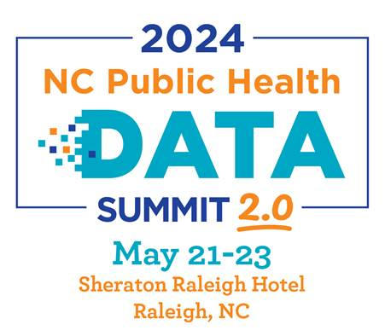
NC Public Health Data Summit 2.0: Building Clarity, Connection, and Capacity to Strengthen the Public Health Data Ecosystem in North Carolina

AGENDA DRAFT – 3.12.24

May 21, 2024: Day 1 - Public health data strategy, considerations, and updates

12:00-1:00 Registration

1:00-2:15pm Opening Session
1:00- Welcome
1:10- Common Language
1:20- NC Data Modernization and Celebrating Progress: Data Modernization, what do we mean and where are we now? A Macro overview of data modernization & public health data ecosystem improvement in North Carolina.

2:30-3:30pm Breakout Sessions
- Opioid Settlement Strategic Planning: Population-level data & story to shape strategy
- Statewide Performance Measure Progress: Presentation from i2i
- Latest Updates on CHA/CHIP/ Scorecard
- Current Opportunities for Funding Enhanced Data Capacity @ the Local-level

3:30-4:00pm Extended Break

4:00-5:00pm Breakout Sessions
- New and Emerging Data Dashboards (Panel)
- Generative AI/Machine learning and potential intersections with PH
- Resources, Reminders, and Possibilities for Understanding Strengths and Needs within Specific Populations (Panel)
- Building Capacity: Regional Learnings

May 22, 2023: Day 2 - Creating and advancing plans for improvement in data processes, partnerships, and systems

8:30-9:30 am Breakfast and Networking

9:45-10:45am Breakout Sessions
- Establishing Data Governance
- Driving Quality Improvement at the Local Level (Panel)
- Data Literacy (Panel): Where are the tools? Where do I get started?
- Data Deep Dives around Population Level Priorities

11:00-12:00am Breakout Sessions
- Lessons Learned from Hospital and Community Data Partnerships (Panel)
- How to Strengthen Your Data Communication Efforts: Tips and Tools
- Data Equity How To: Methods for Equitable Data
- Enterprise Data Management vs Master Data Management: What it can do for your organization and for North Carolinians

12:15-1:15pm General Session: Lunch
- Remarks from National Organizations - Celebrations and Progress

1:30-3:00pm Work Sessions to Create Local Plans and Products
- Data Storytelling
- Enhancing Data Equity
- Local Data Modernization Planning
- Population-Level Data Collection Planning

3:15-4:00pm Event Debrief

7:30pm Networking Meet-up (Optional)

May 23, 2024: Day 3 Collaborative problem-solving around statewide priorities & building beginner and advanced technical skills

8:30-9:30am Breakfast and Opening Remarks
- Circling back on progress from last year
- Overview of the day

9:45-11:45am Tech Work Session/Hack
- Two technical work sessions/hacks TDB

12:00-1:00pm Lunch Break/ Boxed Lunches
- Full group check-in & guidance on afternoon sessions

1:00-4:00 pm Technical Training Drop-in Sessions
Drop-in sessions will have beginner, intermediate, and advanced options
- Excel (Level 1,2,3)
- Clear Impact Scorecard- (Basic Intro, Population, Performance)
- Other Systems and Tools
  - What else is out there?
  - Qualitative (In-Vivo), Quantitative (SAS, STATA)
  - Advanced user discussion session & topics
- Data Communication and Visualization
  - Tableau, Canva, & TBD

