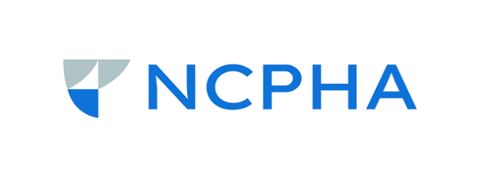

NCPHA Public Health Major Awards Nominations
We all know someone who has achieved great accomplishments, gone beyond the call of duty, made outstanding contributions to public health and/or acted as a motivated champion for public health clients. Let’s celebrate our success and recognize our coworkers! To see the list of past winners, go to https://ncpha.memberclicks.net/award-descriptions.

Award winners will be recognized at North Carolina Public Health Association Fall Educational Conference. Visit NCPHA’s website to learn more about the conference at: www.ncpha.com.

Available Awards:
- Reynolds Achievement Award: Sponsored by the North Carolina Medical Society, this award is bestowed upon the individual member of NCPHA who has made the greatest contribution to public health in North Carolina during the past year. Winner is awarded $500.
- Rankin Legacy Award: This award is given to a NCPHA member in recognition of the outstanding contributions to public health in North Carolina over the member's lifetime. Winner is awarded $1000.
- Distinguished Service Award: This award is given to a NCPHA member for their service to NCPHA. Nominated by the NCPHA Executive Committee. Winner is awarded $250.
- Partners in Public Health Award: Established in 1998, this award is given to organizations and professions outside of public health departments who have made significant contributions to public health in North Carolina over the past year. Winner is awarded an organizational membership to NCPHA.
- Dr. Sarah Taylor Morrow Health Departments of the Year: This award is given to health departments for outstanding programs and efforts. Awarded to two health departments. Winners are awarded $1000.

Requirements:
Nominees must be a current individual or organizational member of NCPHA at the time of nomination. To verify membership status, email Kim Dittmann at kdittmann@ncapha.org. Note that nominees may not win the same award more than once.

Instructions for Nomination Form
- Complete the Nomination Form by July 14, 2023.
- Submit the Nomination Form via: Only emailed forms will be accepted.
  - Email: NCPHA, kdittmann@ncapha.org

NCPHA Major Awards Nomination Form – Word count for the nomination should be no more than 500 words. Please include three bullets that highlight the nominee will be be read if they win.

Name of Award: Click here to enter text.

Information of Nominator
Name: Click or tap here to enter text.
County: Click or tap here to enter text.
Agency: Click or tap here to enter text.
Phone Number: Click or tap here to enter text.
Email:Click or tap here to enter text.

Information of Nominee
Name: Click or tap here to enter text.
County:Click or tap here to enter text.
Agency: Click or tap here to enter text.
Phone Number: Click or tap here to enter text.
Email: Click or tap here to enter text.
Positon/Profession: Click or tap here to enter text.
Years of Service: Click or tap here to enter text.

Narrative
If nominating an individual, describe the nominee and why he/she should be considered for this award. Include information on public health experience, education, outstanding public health experience, organizational affiliations, offices held, important board appointments, and previous awards as necessary.
Click here to enter text.

If nominating an organization, describe the organization and why they should be considered for this award. Include information on outstanding programs, achievements, and recognition for advancements made in public health practice.
Click here to enter text.

