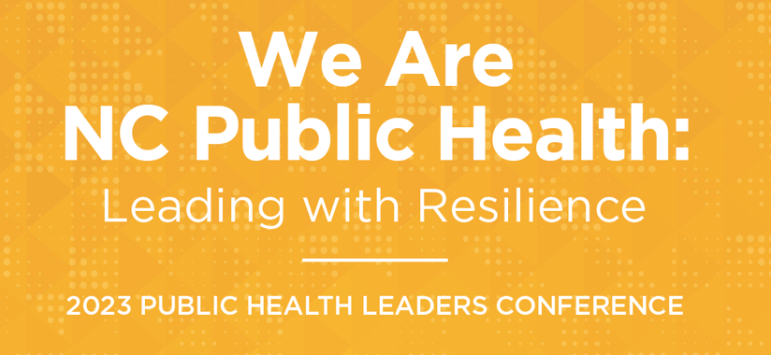

Thursday, March 16, 2023
7:45 – 8:45 | Registration and Continental Breakfast
8:45 – 9:00 | Welcome NC DPH + NCALHD  Video Greetings from Vice Admiral Vivek H. Murthy, U.S. Surgeon General  Dr. Susan Kansagra and Lillian Koontz  President, NC Public Association of Local Health Directors and Davidson County Public Health Director
9:00 – 10:30 | Plenary #1: The Future of Public Health in North Carolina and Beyond  Dr. Susan Kansagra with Rod Jenkins  President, NC Public Health Association and Durham County Public Health Director
10:30 – 10:50 | Break and Exhibitors’ Gallery
10:50 – 12:15 | Plenary #2:  Panel Discussion: Aligning the Stars: NCIOM Future of Local Public Health and Public Health Infrastructure Statewide
12:15 – 12:30 | Break, Exhibitors’ Gallery, and Transition to Luncheon
12:30 – 1:30 | Luncheon, Remarks, and Ronald H. Levine Legacy Award:  Secretary Kody Kinsley and Dr. Susan Kansagra
1:30 – 1:45 | Break, Exhibitors’ Gallery, and Transition to Breakout Sessions
Breakout Sessions
Breakout Session #1 | Breakout Session #2 | Breakout Session #3 | Breakout Session #4 | Breakout Session #5 | Breakout Session #6
A New Trifecta: Equity, Environmental Justice, & Community Health Assessments | DEI – Belonging | Firearm Injuries and Deaths: From Data to Action | Growing the Career Pipeline for Public Health in NC | Working with State and Local Government to Leverage Opioid Settlement Funding for Overdose Prevention | Maternal Morbidity & Mortality – Medicaid, Group Prenatal Care and Doulas
Virginia Guidry,  Joe Bowman,  Arlinda Ellison | Milagros Russell,  Kiva Elliott | Scott Proescholdbell, Anna Waller, Betsey Tilson, Kella Hatcher, Billy Lassiter, Sue Ann Pilgreen, Breanna Culler | TBD | Ashley Wurth, Steve Mange, Nidhi Sachdeva, Tyler Yates | Belinda Pettiford  Emma Sandoe,  Tara Owens Shuler,  Ebony Tate

Breakout Session #7 | Breakout Session #8 | Breakout Session #9 | Breakout Session #10 | Breakout Session #11 | Breakout Session #12 | Breakout Session #13
Using Your Voice: Communication Strategies for Public Health Leaders | Recent increases in syphilis and other STIs | Leading for work-life balance | Reproductive Health | Innovative Approaches for Enhancing Surveillance and Guiding Programmatic Direction | Clean Classrooms for Carolina Kids: An Expansion of the Clean Water for Carolina Kids Program | Suicide Prevention Programs, Tools, and Training in NC
Tracy Zimmerman | Vicki Mobley  Erika Samoff | Morgan White – Continuum Consulting Services | Jill Moore  Jill Sergison  Rocio Anderson | Erica Wilson  Ariel Christensen,  Chris Kippes | Ed Norman, Jennifer Hoponick Redmon | Anne Geissinger, Jane Miller, Abigail Coffey

Friday, March 17, 2023
8:30 – 9:00 | Continental Breakfast
9:00 – 10:00 | Keynote: Resilience and the Workforce: Dr. Lipi Roy  Internal Medicine Physician, Speaker, Writing and Medical News Contributor
10:00 – 10:15 | Break and Exhibitor’s Galleries
10:15 – 11:30 | Panel Discussion: NC State Health Improvement Plan – Partnerships for Health Equity
11:30 – 12:00 | Conference Closing and Remarks:  Betsey Tilson, North Carolina State Health Director and the Chief Medical Officer, NC Department of Health and Human Services

Breakout Session List:
- A New Trifecta: Equity, Environmental Justice, & Community Health Assessments
- DEI – Belonging
- Firearm Injuries and Deaths: From Data to Action
- Growing the Career Pipeline for Public Health in NC
- Working with State and Local Government to Leverage Opioid Settlement Funding for Overdose Prevention
- Maternal Morbidity & Mortality – Medicaid, Group Prenatal Care and Doulas
- Using Your Voice: Communication Strategies for Public Health Leaders
- Recent increases in syphilis and other STIs – Need Form from someone
- Leading for work-life balance
- Reproductive Health
- Innovative Approaches for Enhancing Surveillance and Guiding Programmatic Direction
- Clean Classrooms for Carolina Kids: An Expansion of the Clean Water for Carolina Kids Program
- Suicide Prevention Programs, Tools, and Training in North Carolina

