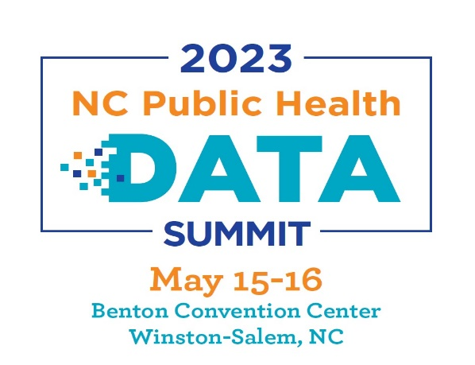
Join us in supporting the convening of up to 300 public health data professionals and enthusiasts working together to strengthen the data ecosystem in North Carolina. Throughout this two-day summit, we will be focusing on data, story, workforce, partnerships, connectivity, technology, and tools.
Gold Sponsor (one available) – $10,000
- Organization name and logo prominently displayed on pre-event information for event, signage at event, weekly E-Blasts, and conference event app.
- Opportunity to exhibit on Monday and Tuesday.
- Six complimentary conference registrations.
- Opportunity to present for 15 minutes at the Exhibitor Reception or Summit Closing Remarks.
Silver Sponsor –$7,500
- Organization name and logo prominently displayed on pre-event information for event, signage at event, weekly E-Blasts, and conference event app.
- Opportunity to exhibit on Monday and Tuesday.
- Four complimentary conference registrations

Bronze Sponsor – $5,000
- Organization name and logo prominently displayed on pre-event information, signage at the event, weekly E-Blasts, and conference event app.
- Opportunity to exhibit on Monday and Tuesday during the conference.
- Two complimentary conference registrations

Sponsor of Public Health Data – $2,500
- Organization name and logo prominently displayed on pre-event information, signage at the event, weekly E-Blasts, and conference event app.
- One complimentary conference registration

