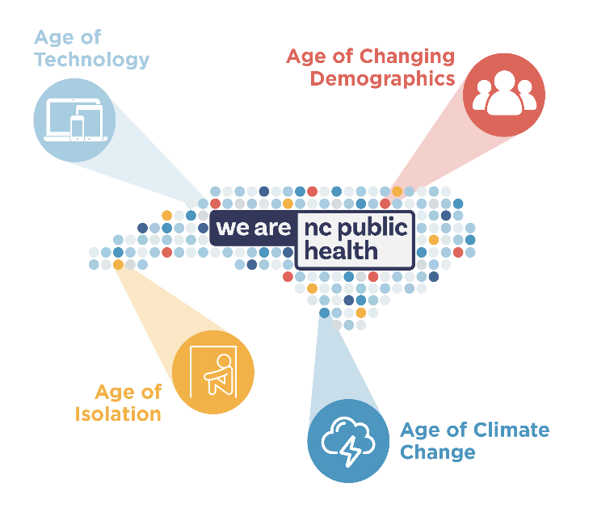

Public Health Leaders’ Conference Draft Agenda
March 13-14, 2025
Embassy Suites Raleigh/Durham/Research Triangle

Breakfast 7:30 am

Thursday, March 13, Opening Session – 9:00 am – 12:00 pm
John Auerbach, ICF International – Topic - AI
Dr. James Johnson, Kenan-Flagler School of Business, UNC-CH – Leading in Certain Uncertainly

Lunch Buffett – 12:00 – 1:30 pm

Thursday Breakout Topics – 1:30 – 4:45 pm
Policy Tract –
- Starting with Policy – Mecklenburg County Public Health Office of Chronic Disease Policy and Prevention
- T21 and Cannabis Panel
- Impact of SL2024-49 on Local Environmental Health Practice

Community Partnership and Preparedness Tract –
1. Carolinas Poison Control and PHPR
2. Leveraging Outreach for Emergency Preparedness
3. Use of Human Skills and Technology to Access Private Well Owners After
Hurricane Helene

Surveillance and Assessment Tract –

- Incarceration and Health: Managing Communicable Diseases and Outbreaks
- What We Know Works: Firearm Violence Prevention Panel
- Public Health Actions to Address Extreme Heat in NC

Organizational Competencies and Workforce –
1. Utilizing Quality Improvement Methods to Address Immunization Health Equity
2. Data Modernization (ETOR) SLPH Preview
3. Agreement Addenda QI Project: Creating Procedure out of Practice

Equity in Practice Tract –
1. Increasing Access: ECBI Public Health Vending Machines
2. Outside the Doctor’s Office: Using AI to Uncover Social Drivers of Health
Disparities
3. Equity Data: A Practical Guided Tour
4. Firearm Safety Test Teams: American Foundation for Suicide Prevention

Communications Tract –
- Earning Trust in Public Health
- Your Elevator Pitch: Telling Your Story
- Frameworks in Review: Messaging Public Health
- Multimedia Strategies: Beyond the Press Release – Lessons Learned from the Helene Response

Friday, March 14 – Closing Session – 9:00 am – 12:00 pm
Breakfast 7:30 – 9:00 am
Ryan Jenkins, Connectable – Age of Isolation
Climate Change Panel

