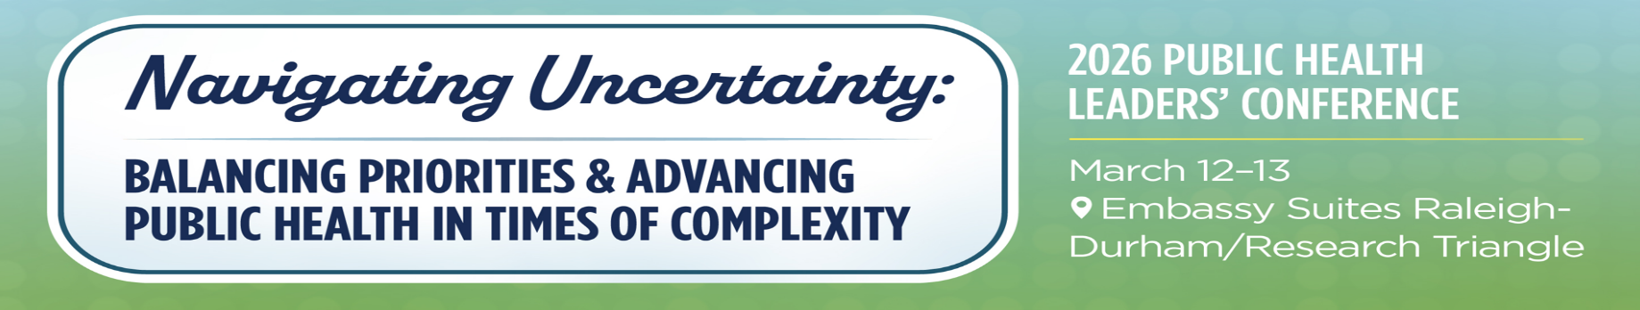

2026 PUBLIC HEALTH LEADERS’ CONFERENCE AGENDA AT A GLANCE
THURSDAY, March 12, 2026: DAY 1 Public Health Leaders’ Conference
7:30 – 9:00 am Registration & Breakfast Pre-function
9:00 am – 5:00 pm Exhibits and Posters Open Pre-function
9:00 – 9:30 am Opening Remarks: Dr. Kelly Kimple, Division Director, NC DPH & Jen Greene Ballroom
President, NC Association of Local Health Directors (NCALHD)
9:30 – 10:30 am Keynote Address: Public Health Leadership in Times of Uncertainty
Mandy Cohen, MD, MPH, National Advisor, Manatt Health Ballroom
10:45 – 11:45 am Leadership Principle Plenary: Cultivating Inner Strength & Resilience as Leaders
Kristin Neff, PhD, Self Compassion Institute Ballroom
11:45 am – 1:00 pm Lunch and Presentation of the Dr. Ron Levine Award Ballroom
1:30 – 4:45 pm Breakout Sessions
Breakout Tract | 1:30p-2:30pm |  | 2:45p-3:45pm |  | 4:00p-4:45pm
Surveillance & Assessment | Vaccine-Preventable Disease Trends: Challenges and Opportunities |  | Information for decision-making. Surveillance systems updates |  | Resolving the Uncertainty of Drug-Impaired Driving
Location/Room | Smith |  | Smith |  | Smith
Addressing Gaps in Health | NC Environmental Public Health Tracking Program Water Filter Distribution Project |  | Building Bridges for Control of HIV and Other Diseases |  | NC Programs' Holistic Approach to Address Infant Mortality
Location/Room | Cameron |  | Cameron |  | Cameron
Communications | Being trustworthy & earning trust - what the data tells us, as lessons from life |  | Exploring New Technology & Collaborating Regionally to Advance Local Public Health Communications |  | Overview of NC Injury Data User Toolkit & How it Can Help You Better Understand Data
Location/Room | Reynolds |  | Reynolds |  | Reynolds
Policy Development & Support | Rules That Protect: Improving Public Health Through Rulemaking |  | Moving MMRC Recommendations to Action: Statewide Strategies to Reduce Maternal Mortality |  | Legal Mandates vs. Staffing Realities: Strategies for Maintaining CD Compliance in LHDs
Location/Room | Cape Hatteras |  | Cape Hatteras |  | Cape Hatteras
Organizational Competencies | From Support Tool to Organizational Asset: Navigating the Spectrum of AI Use in Public Health |  | Workforce Development and Nurturing the Public Health Workforce Panel |  | Building Systems to Support Chaos: Control What You Can Control
Location/Room | Bellamy/Mendenhall |  | Bellamy/Mendenhall |  | Bellamy/Mendenhall
Community Partnerships & Preparedness | Community-level surveys for preparedness and response: Case studies from two hurricane events in NC |  | PHAT- Bringing the Assistance to You in an Emergency |  | Currency of Collaboration: Funding Stability Through Partnership Innovation
Location/Room | Biltmore/Hope |  | Biltmore/Hope |  | Biltmore/Hope
FRIDAY, March 13, 2025: DAY 2 Public Health Leaders’ Conference

7:30 – 9:00 am Breakfast Ballroom
9:00 – 9:30 am Opening Remarks: Dr. Devdutta “Dev” Sangvai, Secretary of NC DHHS Ballroom
9:00 – 10:00 am Public Health in Action Panel: Money Matters - Understanding &
Strengthening the State & Local Public Health Funding Ecosystem Ballroom
10:15 – 11:30 am Send-Off Keynote: Motivation in Adversity and Uncertainty (Working Title)
Mike Schlappi, Motivational Speaker & Olympic Champion Ballroom
11:30 am – 12:00 pm Closing Remarks: Dr. Kelly Kimple, Division Director, NC DPH Ballroom

Map of Conference Facility: Embassy Suites

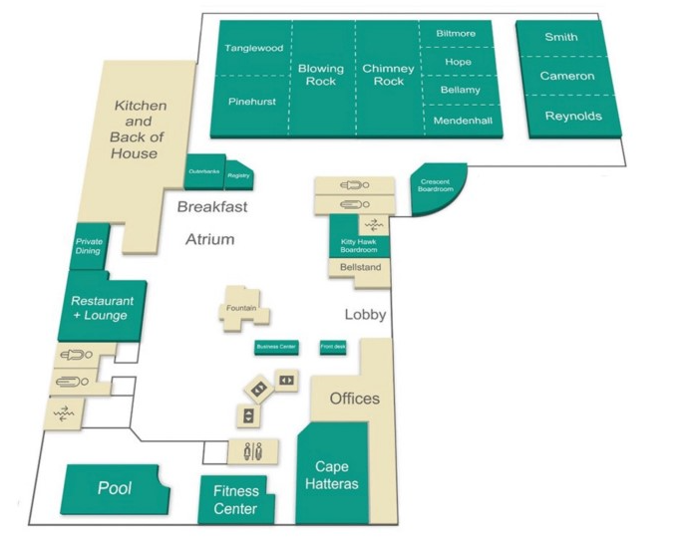


Please download the NCPHA Conference App using the QR codes placed around the venue or visit the App Store on your phone with NCPHA keyword.
Connecting to WiFi:
Password: PHL2025

NOTES:

