|  |
| --- |
| **2020 Community Health Assessment**  **Winter Institute** |
| **“Healthy North Carolina 2030 &**  **Results-Based Accountability”** |
| **January 22, 2020** |
| **North Raleigh Hilton**  **Raleigh North Carolina** |

**Conference Objectives**

* **Recognize and apply the HNC 2030 indicators to the community health improvement planning (CHIP) process locally**
* **Practice writing CHIPs for Healthy 2030 indicators using Results-Based Accountability** **TM**
* **Explore Scorecard TM as a tool for capturing CHIPs dynamically**
* **Review basic requirements for CHAs, CHIPs, and SOTCH**

**Course Credit:** Application for CHES (entry-level)/MCHES (advanced-level) Category I continuing education contact hours (CECH) has been made to the National Commission for Health Education Credentialing, Inc. (NCHEC).

CHA coordinators are asked to bring the most recent copy of the following documents to the Institute. These will be used for self-assessment in tabletop activities:

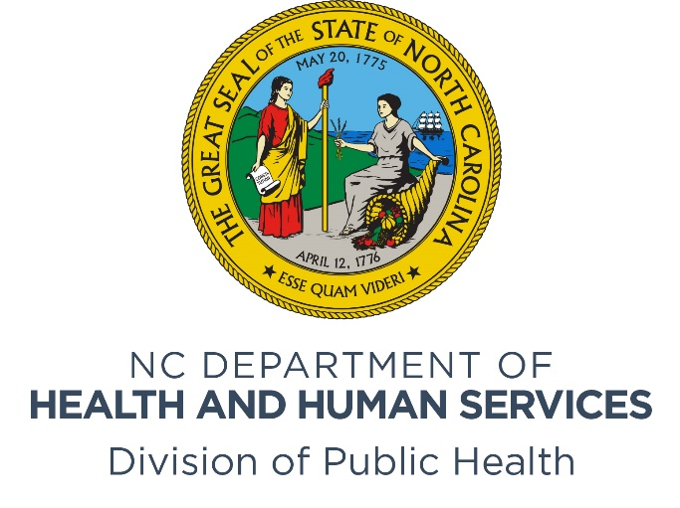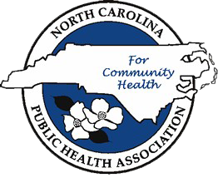

|  |  |
| --- | --- |
| 8:30 am - 8:50 am | Welcome  Mark Benton, Assistant Secretary for Public Health  NC Department of Health and Human Services  Elizabeth Cuervo Tilson, MD, MPH |
| 8:50 am - 9:00 am  9:00 am- 9:45 am | State Health Director  Chief Medical Officer  NC Department of Health and Human Services  Announcements  Kathryn Dail, State Center for Health Statistics  NC Department of Health and Human Services  “Healthy North Carolina 2030”  Brianne Lyda-McDonald, North Carolina Institute of Medicine  Berkeley Yorkery, North Carolina Institute of Medicine |
| 9:45 am - 10:00 am | Break |
| 10:00 am- 12:00 pm | “HNC 2030 Data Walk”  Rapid Round Presentations  Grand Ball Room II |
| 12:00 pm - 1:00 pm | Lunch & Recognitions |
| 1:00 pm - 1:30 pm  2:30- 4:00 pm | “Results Based Accountability and CHIP Requirements”  Kathryn Dail, State Center for Health Statistics  “Tabletop Exercises: Results-Based Accountability & Clear Impact Scorecard”  Facilitators TBD |
|  |  |
| 4:00 pm- 4:30 pm | Closing Remarks and Evaluation  Delton Atkinson, Interim Director  State Center for Health Statistics  NC Department of Health and Human Services |
|  |  |

