Exploring the living conditions in Public Housing
that impact health and safety in Craven and Durham Counties.

By Bibianna Contti REHS, Craven County Health Department, Stephanie Garcia Project BUILD-Bilingual Outreach, Durham County Health Department, and Kelsey Ross Dew, MATCH Wellness VP for Program Delivery and Expansion

Introduction
North Carolina had an estimated population of 10.38 million in 2018. (North Carolina). In the US, ten million individuals in over five million low income households receive rental assistance to afford modest housing. In NC, 263,000 individuals in 138,000 households receive rental assistance and four in ten low-income people in North Carolina are homeless or pay over half their income for rent (www.cbpp.org) (See Figure 1). In Craven county, 33 percent of all households are cost-burdened, meaning that 30 percent or more of their monthly income goes to housing costs or rent (Craven County Health Department, 2019).
Figure 1. Federal rental assistance programs provided North Carolina with $874 million in 2018 (www.cbpp.org).
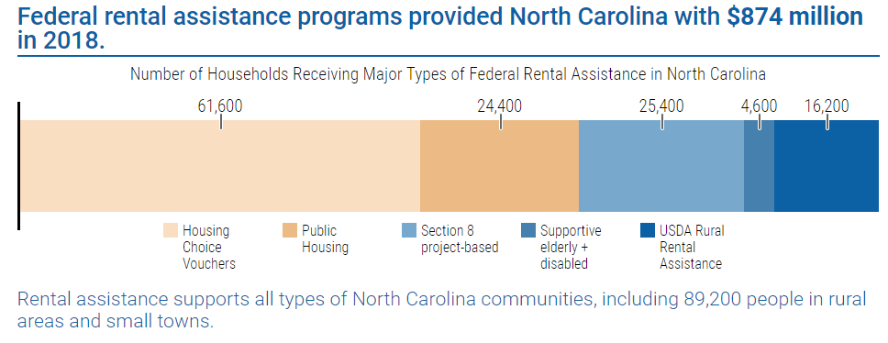

Although North Carolina is providing public housing to a large amount of its population, statistics still show that more than 1.2 million North Carolinians cannot find affordable housing and one in 28 of our state’s children under age 6 is homeless (www.ncdhhs.gov). Research shows that health is poorer among residents of public housing. In addition, safety is major a major concern in public housing communities (Digenis-Bury, Brooks, Chen, Ostrem & Horsburgh, 2008; Hayward, et al., 2015). The research in this area is limited, especially among North Carolina public housing residents even though there are counties with a large percent of the population relying on housing assistance.

The purpose of this study is to explore the living conditions that impact health and safety in two counties, Craven and Durham. Craven County has a population of 102,912 as of 2018 and is located on the East Coast of rural North Carolina. Durham County has a population of 274,291 as of 2018 and is located in Central North Carolina with a large city in the center (Census.gov).
In this study, we originally wanted to specifically examine the main concerns of Public Housing Assistance recipients. However, our research team could not ensure the proper steps be taken due to limited resources to survey the population in public housing. There haven’t been enough studies completed on North Carolina public housing residents to determine a conclusive relationship. Instead, the study direction changed to sample employees who assist Public Housing Assistance recipients that are currently living or requesting assistance in the two counties.
Methods
A qualitative survey was conducted to explore what the main concerns are with regard to the living conditions for low-income families in Public Housing that impact health and safety in Durham and Craven counties. The survey was designed to have three open ended questions:
- What is the most common complaint about public housing as it relates to health or safety?
- What is the main reason low income individuals come back to request new housing?
- What is being done to address the most common complaint in public housing as defined in number 1?
Open ended questions were provided to allow people to freely respond to the questions and ensure we could obtain qualitative data. Sixty surveys were hand delivered to different employees that work directly with individuals in public housing such as Social Workers, Housing Authority, and Case Workers.
After the surveys were completed, the data was compiled and transcribed by a member of the research team and subsequently analyzed to understand what common themes emerged.
Only 18 surveys were completed out of the 60 giving a 30% response rate completed between the two counties. The low response rate was due to employee hesitation with answering the questions. Most of the employees directed members of the research team to their Program Managers or Supervisors. Team members had to explain that the responses had to come directly from employees who worked with clients directly. Several employees still stated they did not feel comfortable answering these questions.

Results
The results showed that the most common complaints about public housing as it relates to health or safety, are mold, high crime rates, and lack of repairs. As one respondent stated, “One of the most common complains about public housing is [landlords] not repairing what needs to be repaired in the home.” Yet another respondent pointed to specific consequences of lack of repair: “Lack of thorough maintenance which leads to lead exposure and other harmful conditions.”
When asked about the main reason for repeat requests for public housing, respondents said eviction/affordability, general condition of the house, and safety concerns. One response was, “Individuals feel unsafe” while another respondent felt that “new housing request is often because they cannot afford the place they are living in. Affordable housing is difficult to find. Affordable and safe.”
The final question on the survey asked what respondents’ perceptions about what is being done about mold, safety and maintenance (as defined in number 1), which seemed to be the most difficult for respondents to answer based on the limited responses for this question. Four of the 18 respondents did not know how to respond. The most common answer was that nothing is being done and what is being done is not effective, referring to how landlords are often protected by NC laws and tenants may face retaliation if they complain about. As on respondent shared “In my opinion, nothing, nothing effective. Tenants that complain about issues are often evicted and others don’t [complain] because they fear retaliation.”

Research
Safety was cited as a major concern that emerged across the respondents in both counties, both for the first as well as the second question on the survey. Durham County has five census tracks that are identified as Qualified Opportunity Zones (QOZ’s). In the image below we show those zones. Within the zone’s there are areas that are outlined in orange shows the area of Public Housing in that particular zone (See Figured 2).

Figure 2. Durham County Qualified Opportunity Zones
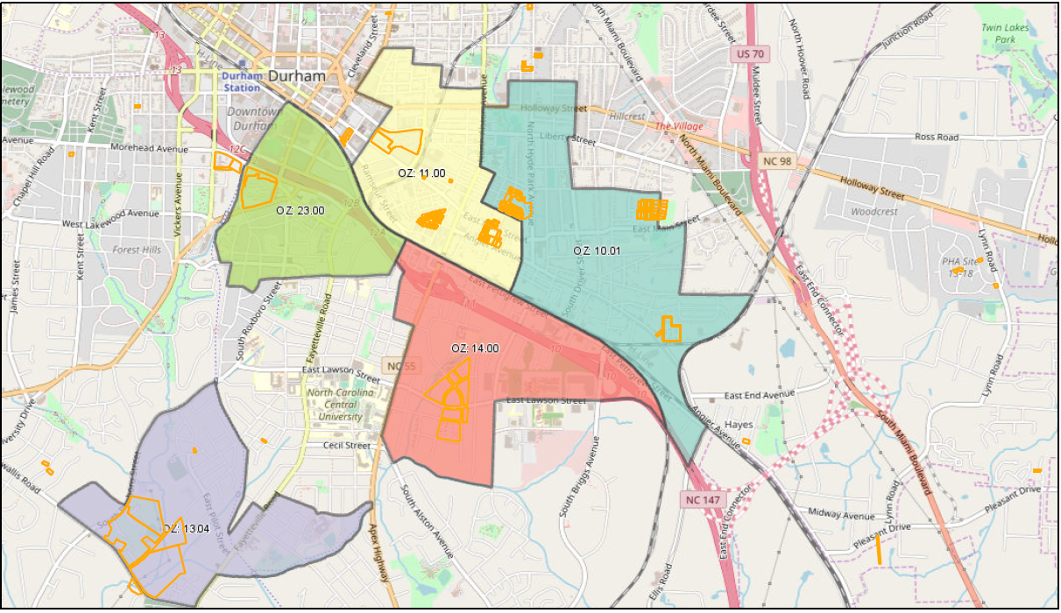

The table below breaks down the census tract by population, poverty level and crime committed by juvenile from 2016 to end of May 2019, 2218 crimes were committed by youth under the age of 18. Of those crimes, 535 were to person, 1378 to property and 305 to society. Juvenile crime rates for the QOZ’s are significantly elevated when compared to other areas of the city. This crime is only addressing juvenile, we can only imagine what it would be for adults. Violent crime was also identified as the top community issue among Hispanic/Latino neighborhood respondents when surveyed during the 2017 Durham County Community Health Assessment (Durham County Health Department, 2017). Violent crimes in Durham county increased by 21 percent from 2007 to 2016 (Durham County Health Department, 2017).

Table 1. Crime by QOZ Census Tract in Durham County
QOZ Census Tract | Population | Poverty Level of residents ages 18 and under | Juvenile crime incidents reported in 2016 to May 2019
10.01 | 3,801 | 36% | 80
11.00 | 3,425 | 64% | 62
13.01 | 3,305 | 58% | 75
14.00 | 2,375 | 87% | 88
23.00 | 1,346 | 47% | 24

In Craven County, violent crimes have fluctuated since 2013 as shown in the figure below, however the crime rate was higher in 2016 than in 2014 and 2015 (See Figure 3).
Figure 2. Craven County Crime Rates 2013-2016 from the 2019 Craven County Community Health Needs Assessment
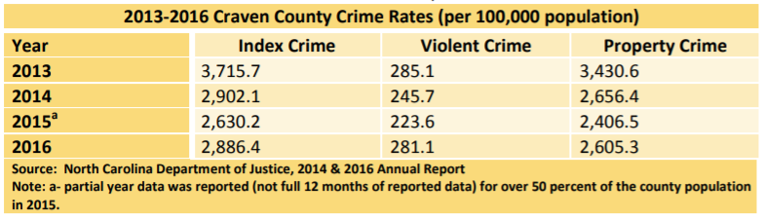

One respondent mentioned there is not enough public housing in Durham County which was echoed in a local news article reporting on the severe lack of affordable housing in Durham. The members of the city council are aware of this crisis and have a plan of $1.5M in place. The plan aims to use $750,000 which would be used to rehabilitate 14 rental homes; $327,250 for another seven rental units; $300,000 for Habitat for Humanity to make minor repairs on homes of low-income, and; $500,000 in the dedicated housing fund recommended for neighborhood stabilization projects (Vaughan, 2018). If accepted, the plan will help address the lack of available public housing in Durham County. Additionally, affordable housing was named the top health priority in the 2018 State of the County Health Report for Durham County (Durham County Health Department, 2018) and in the 2017 Durham County Community Health Assessment (Durham County Health Department, 2017). According to the 2017 Durham County Community Health Assessment (2017), “renters make up 40 percent of households in Durham and almost half of them are defined as cost-burdened.”
Given that Craven County was severely impacted by Hurricane Florence, the research team was not surprised to see mold as a top concern among public housing residents. Hurricane Florence has had devastating impacts in Craven County since it’s landfall on September 15, 2018. County wide, structural damage from Hurricane Florence topped the $200 million mark. In New Bern (Craven County Seat) alone, more than 4,300 homes and 300 businesses were damaged or destroyed in the storm, with an estimated $74.5 million in residential damage and $25.6 million in commercial damage. Many families presently have no choice but to live in unsanitary or unsafe conditions.
About a third of households in Craven County are considered cost-burdened by the North Carolina Housing Coalition. This means more than 30 percent of a family’s budget is committed to rent and utilities. This is due to the average rent for a modest two-bedroom apartment in Craven County is nearly 20 percent higher than what the average renter in Craven can afford, according to 2016 data collected by coalition. During the 2019 Craven County Community Health Needs Assessment, 23 percent of respondents stated that more affordable housing was a service or resource that needed most improvement in their community (Craven County Health Department, 2019).

Conclusion
From the data and their extrapolation, the research team recommends increasing communication between the community and the Public Housing Administration. Durham and Craven counties are very different in the social and environmental variables affecting public housing, thus tailoring programs by community to address the real concerns should be integral to any program. The lack of communication between tenants and landlords for repairs of apartments is apparent in both communities. The first recommendation is for residents to be informed of the process for completion of repairs and streamline the process. The next recommendation is to implement more crime intervention programs in public housing areas to increase neighborhood safety and increase public awareness of current crime prevention initiatives happening in the community. In Craven County specifically, there is a need for increased allocated funding for hurricane assistance that includes repairs for public housing. Finally, affordable housing needs to be addressed at the state and local levels to reduce the proportion of cost-burdened residents in both communities. Although affordable housing has been identified as a major concern among community members in previous surveys and the current research, the problem is continuing to jeopardize the health of residents in Durham and Craven counties along with increasing crime rates and lack of repairs being made in homes for residents.

References

Craven County Health Department. (2019). Craven County Community Health Needs Assessment. Retrieved from https://www.cravencountync.gov/DocumentCenter/View/7639/2018-Craven-County-Community-Health-Assessment-
Digenis-Bury, EC., Brooks, DR., Chen, L., Ostrem, M. & Horsburgh, CR. (2008). Use of a population-based survey to describe the health of Boston public housing residents. AM J Public Health 98(1): 85-91. https://www.ncbi.nlm.nih.gov/pubmed/18048798
https://www.cbpp.org/research/housing/national-and-state-housing-fact-sheets-data Retrieved 8/21/19
Durham County Health Department. (2018). Durham County 2019 State of the County Health Report. Retrieved from https://healthydurham.org/cms/wp-content/uploads/2019/04/2018-Durham-County-SOTCH-Final-03012019.pdf
Durham County Health Department. (2017). 2017 Durham County Community Health Assessment. https://healthydurham.org/cms/wp-content/uploads/2018/04/2017-CHA-FINAL-FOR-PRINT.pdf
Hayward, E., Ibe, C., Hunter Young, J., Potti, K., Jone, P., Pollack, CE., & Gudzune, KA. (2015). Linking social and built environmental factors to the health of public housing residents: a focus group study. BMC Public Health 15: 351 https://www.ncbi.nlm.nih.gov/pmc/articles/PMC4404077/#CR4
North Carolina. 1 July 2018. 30 July 2019. <https://www.census.gov/quickfacts/fact/table/NC,cravencountynorthcarolina/PST045218>.
"North Carolina Federal Rental Assistance Fact Sheet." 14 May 2019. Center on Budget and Policy Priorities. 30 July 2019.
Vaughan, Dawn Baumgartner. Durham in an 'affordable housing crisis,' council members say. Durham, 21 March 2018.

Appendix 1: Survey Responses
Resp. | 1. What is the most common complaint about public housing as it relates to health or safety? | 2. What is the main reason low income individuals come back to request new housing? | 3. What is being done to address the most common complain in public housing as defined in number 1?
1 | Mold, poor insulation and high levels of crime | Often clients are unable to sustain. They are not taught to be self-sufficient, instead they put in situation with not guidance or support. | In my opinion, nothing, nothing effective. Tenants that complain about issues are often evicted and others don’t because the fear retaliation.
2 | Unsafe neighborhoods; mold; pest | They get evicted for non payment | Don’t know
3 | One of the most common complains about public housing is not repairing what needs to be repaired in the home. Also having mold in the home and can not get the mold removed. | One of the reasons individuals come back for new housing by not being to have the repairs repaired. | I do not know that answer to that.
4 | There has been an increase in bed bugs over the last year | New housing request is seen often because they cannot afford the place they are living in. Affordable housing is difficult to find. *Affordable and safe* | Most apartments will spray for free once and if it happens again the client will have to pay. However in most new leases the clients are being held responsible for the cost which can be very expensive.
5 | The most common complaint is that public housing is unsafe environment for elderly and children due to the face they are located in high crime areas | Violations of tenant rights by landlord. Home not being maintained properly by landlord. | Durham County has branched out income cased properties where they are now located all over Durham Co. and not just in high crime areas.
6 | Lack of thorough maintenance which leads to lead exposure and other harmful conditions; high crime rate | Individuals feel unsafe | Having apartments such as city inspectors to ensure units are up to code however the majority who reside in public housing lack knowledge of these resources; police hubs that are stationed in public housing neighborhoods.
7 | Maintenance is not kept up | Too many issues with existing house | Nothing; housing laws in NC are designed to protect landlords not tenants.
8 | Total lack of availability. Too few units in safe communities. | Even a minor crisis becomes a major financial burden when there is zero emergency fund or plan for the inevitable- this leads to late rent or even eviction. | The city has several affordable housing projects in projects in production. However, the availability of housing does not have a ‘single’ answer to solve. There needs to be multiple ways to deal with it involving both the public and private sectors.
9 | Mold and no proper insulation | Because the old house has major health issues | Landlords are trying to fix the problem by fixing the damages
10 | Violence, loud noises, drug usage/sales, guns, gang activities, low school attendance; unsafe for children, neglect/abuse, low birth rates/Some parents may be up late at nights which may affect their abilities to adequately care for their children and compromise their education/health and wellbeing; poor maintenance of the building, bugs, roaches, rodent, graffiti; people hanging out in the area that does not live there, people living in public housing that are not on the lease, low employment/underemployment, low skills/low functioning, single parent household, fathers of the children are often in jail of prison, domestic violence. | Property destruction/eviction; some may lack the feeling/sense of ownership/belonging; lack of employment or adequate skills to maintain employment, low wages, broken relationships with landlords/support systems, lease violations, refusal to pay rent if they perceive that they are the victim in a situation; refusal to address challenges/barriers that may have contributed/hinderance of personal family growth. | Improved police presence in the areas thus sometimes resulted in killing of residents; more mental health, Child Protective Service and other interventions by advocates and service providers; Mobile Units providing dental and other health related services; longer clinical hours or additional outpost provided by Lincoln Community Health Centers and Duke Hospital; Lawyers volunteering time and skills to work on expungement to remove some of the barriers to gainful employment.
11 | Delayed repairs; poor management; tenants don’t have a voice | Lack of repairs to their homes | More inspections
12 | Homes not located in safe environments to raise children | Poor living conditions; homes in gang areas; home unsafe for family due to gun violence | Nothing to my understanding
13 | Too small; flooding; gun shots | Too small | Don’t know
14 | Not maintained very well by the owners. Slow to fix problems like heat and air | In hopes of better living conditions | Not sure if its being addressed
15 | Lights not being repaired | Better place to raise kids- safer | They fix bulbs, but same tenants break them
16 | Maintained sub-standardly | Expired certification | Not sure
17 | Mold | AC and heat | Nothing
18 | Mold, bug infestation, flooding, sound of gun shots |  | nothing

