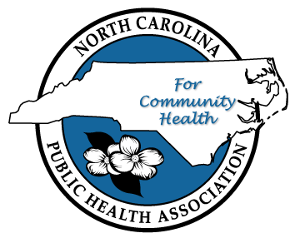
NC Public Health Association
2021 Fall Educational Conference
Sponsorship Opportunities
The North Carolina Public Health Association (NCPHA) is the premiere non-profit member association serving public health and allied health professionals across North Carolina. NCPHA was formed in 1909 by a group of concerned county superintendents of health in an effort to promote public health in NC. More than 100 years later, NCPHA members and partner organizations continue working to improve the public’s health through political advocacy, public awareness, professional development, and serving as an interface between research and practice.
Gold Sponsor – Conference Event Bags: $10,000 (1 available)
- Organization name and logo prominently displayed on pre-event information, signage at the event, and on weekly E-Blasts. One page ad in conference agenda.
- Opportunity to exhibit on Wednesday and Thursday during the conference.
- Six complimentary conference registrations
- Sponsor of event bags with your logo which will be distributed to all attendees.
Gold Sponsor – Scholarship Walk: $10,000 (1 available)
- Organization name and logo prominently displayed on pre-event information, signage at the event, and on weekly E-Blasts. One page ad in conference agenda.
- Opportunity to exhibit on Wednesday and Thursday during the conference.
- Six complimentary conference registrations
- Sponsor of NCPHA Scholarship Walk. Your logo displayed on walk t-shirts.

Gold Sponsor – Thursday Breakfast: $10,000 (1 available)
- Organization name and logo prominently displayed on pre-event information, signage at the event, and on weekly E-Blasts. One page ad in conference agenda.
- Opportunity to exhibit on Wednesday and Thursday during the conference.
- Six complimentary conference registrations
- Sponsor of Thursday Breakfast. Opportunity to speak for 30 minutes at Thursday breakfast.
Silver Sponsor – Section Session Sponsor: $7,500 (3 available)
- Organization name and logo prominently displayed on pre-event information, signage at the event, and on weekly E-Blasts. ½ page ad in conference agenda.
- Opportunity to exhibit on Thursday during the conference.
- Three complimentary conference registrations
- Sponsor of one section’s session with opportunity to present for 15 minutes at the beginning of a session. NCPHA to provide list of available sessions.
Bronze Sponsor – Hospitality Suite Sponsor: $5,000 (2 available)
- Organization name and logo prominently displayed on pre-event information, signage at the event, and on weekly E-Blasts. ¼ page ad in conference agenda.
- Opportunity to exhibit on Thursday during the conference.
- Two complimentary conference registrations
- Sponsor of Hospitality Suite for one night during the conference.

Friend of NCPHA Sponsor – $2,500 (unlimited)
- Organization name and logo prominently displayed on pre-event information, signage at the event, conference agenda, and on weekly E-Blasts.
- Opportunity to exhibit on Thursday during the conference.
- One complimentary conference registration

The NCPHA Fall Educational Conference attracts more than 500 state public health professionals each year. The conference addresses current and emerging health science, policy, and practice issues in an effort to prevent disease and promote health. The conference offers your organization the opportunity to gather, learn, and network with our attendees and support public health in North Carolina.
Please make your commitment by July 16
2021 Fall Educational Sponsorship Information and Registration Form:
https://ncpha.memberclicks.net/fall-educational-conference-exhibitor-information

