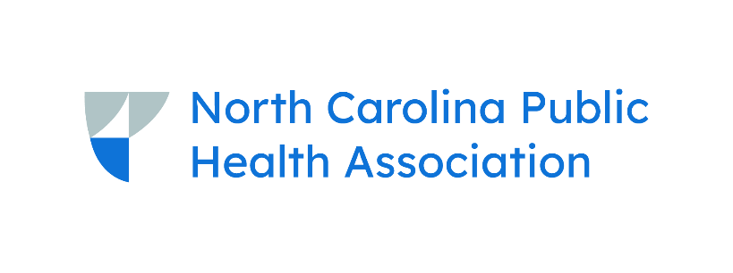
2025 Pre-FEC Communications Program
September 16, 2025 | Wilmington, NC
Draft Agenda (07.22.2025)
- 9:00-10:00am Registration
- 10:00-11:00am Opening Session
- 10:00am Welcome, Bethany Milford, MPH, NC Public Health Collaboration
- 10:10am What I’m Hearing Across the Country: A Public Health Communications Roadmap, Amanda Kwong, MPH, Public Health Communications Collaborative
11:15-12:15pm Breakout Sessions
- Bringing the Message Home: Health Communication in Media-Limited Communities, Kyle Pasche, Chatham County Public Health Department
- Using Data for Effective Communication
- Message Mapping: Sharing Information & Supporting Data, Ann Staples, MA, MCHES
12:15-1:15pm Lunch
- Campaign Updates, Suzanne Metcalf, NC DPH, NC DHHS
- Collaborative Communications Network Update, Martha Anne Sperandio, MPH, North Carolina Institute of Public Health
1:30-2:30pm Breakout Sessions
- Media Training Workshop, Amy Joy Lanou, North Carolina Institute of Public Health
- The Value of Collaboration, Brandon Romstadt, WNC Health Network
- Social Media Strategies and Storytelling/Strategic Messaging for Public Health, Samantha McClayton and Jeremy McClayton, JS Consulting & Marketing
2:30-3:00pm Snacks available
2:45-4:45pm Afternoon Workshop
- Jumpstart Your Fall Campaigns with Arclet: A Hands-On Public Health Communications Workshop, Adrienne Ammerman, Arclet
4:45-5:15pm Event Debrief/Closing
6:00pm Evening Meet-up (Optional)

