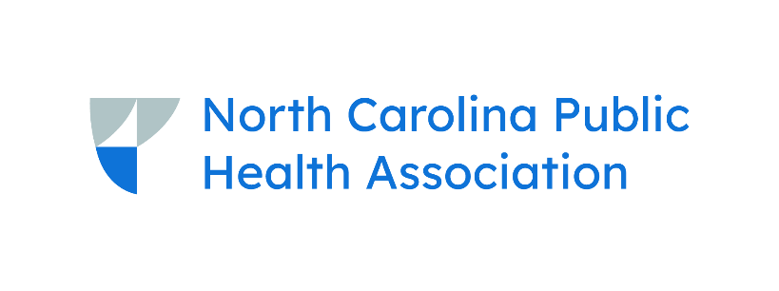
2025 Pre-FEC Communications Program
September 16, 2025 | Wilmington Convention Center
Draft Agenda (08.26.2025)
9:00-10:00am Registration
10:00-11:00am Opening Session Salon A
- 10:00am Welcome
  - Bethany Milford, MPH | NC Public Health Collaboration
- 10:10am What I’m Hearing Across the Country: A Public Health Communications Roadmap
  - Amanda Kwong, MPH | Public Health Communications Collaborative
11:15-12:15pm Breakout Sessions
- Bringing the Message Home: Overcoming Communication Barriers in Rural Communities Salon D
  - Kyle Pasche | Chatham County Public Health Department
- Message Mapping: Sharing Information & Supporting Data Salon B
  - Ann Houston Staples, MA, MCHES
  - Scott Proescholdbell | NC DHHS
- Powering Up Your Productivity: Using AI & Time-Saving Hacks Salon C
  - Nicole Hricik | Union County Government
12:15-1:15pm Lunch Salon A
- Campaign Updates
  - Suzanne Metcalf | NC DPH, NC DHHS
- Collaborative Communications Network Update
  - Martha Anne Sperandio, MPH | North Carolina Institute for Public Health
1:30-2:30pm Breakout Sessions
- Amplifying Your Message by Working With News Media Salon D
  - Amy Joy Lanou, PhD | North Carolina Institute for Public Health
- The Value of Collaboration (Panel) Salon B
  - Brandon Romstadt | WNC Health Network
  - Emily Ranck, MPH | WNC Health Network
  - Clarissa Ashe | Jackson County Health & Human Services
  - Stacey Wood | Buncombe County Government
  - Adrienne Ammerman, MPH | Arclet
  - Megan Rollins | Foothills Health District
- Strategic Messaging & Social Media Strategies in the Current Public Health Climate Salon C
  - Samantha and Jeremy McClayton | JS Consulting & Marketing
2:30-3:00pm Snacks available
2:45-4:45pm Afternoon Workshop Salon A
- Jumpstart Your Fall & Winter Campaigns with Arclet: A Hands-On Public Health Communications Workshop
  - Adrienne Ammerman, MPH | Arclet
4:45-5:15pm Event Debrief/Closing
6:00pm Evening Meet-up (Optional)

