**We Are Proud to Announce**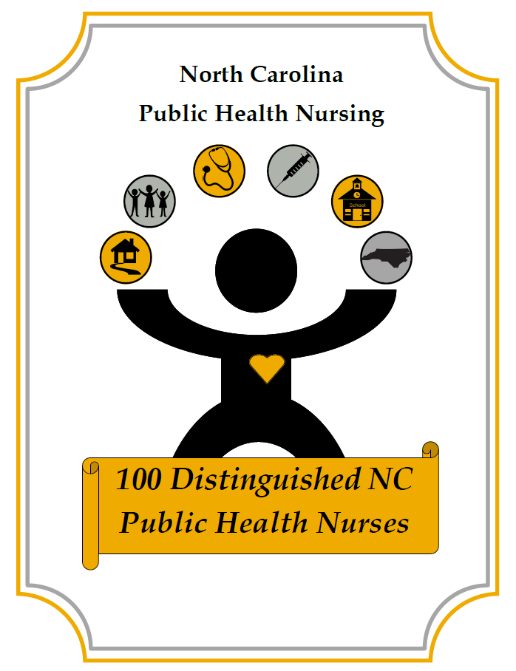

**As Part of the 100 Years of the Office of Public Health Nursing Centennial Celebrations**

|  |  |  |
| --- | --- | --- |
| Myra | Allen | NC DHHS DPH Communicable Disease Branch |
| Mary | Backlund | Buncombe County Health and Human Services |
| Beverly | Barber | Forsyth Co Dept of Public Health |
| Tara | Bartasavich | Wake County Human Services |
| Penny | Bell | Guilford County Division of Public Health |
| Donna | Biederman | Duke University School of Nursing |
| Jenna | Brinn | Hyde County Health Department |
| Barbie | Britt | Robeson County Health Department |
| Laura | Bryant | Cabarrus Health Alliance |
| Tiffany | Bullins | Surry County Health & Nutrition Center |
| Awanya | Caesar | Lincoln Community Health Center |
| Angela | Callicutt | NC DHHS DPH Children & Youth Branch |
| Theresa | Carpenter | Jones County Health Department |
| Mary Katherine | Carpenter | Durham County Department of Public Health |
| San San | Cho | Guilford County Department of Public Health and Human Services |
| Denise | Clubb | Buncombe County Health and Human Services |
| Marianne | Cockroft | UNC at Chapel Hill School of Nursing |
| Maren | Coffman | University of North Carolina at Charlotte |
| Jill | Cogdill | Cleveland County Health Department |
| Lynn | Conner | NC DHHS DPH Public Health Nursing & Professional Development Unit |
| Denise | Courtney | Union County Health Department |
| Betty | Cox | NC DHHS DPH Women's Health Branch |
| Susan | Creede | Buncombe County Health and Human Services |
| Patricia | Davis | Harnett County Health Dept |
| Jean | Davison | UNC Chapel Hill School of Nursing |
| Vicki | Deem | NC DPH Cancer Prevention and Control Branch |
| Jennifer | Dennis | Mecklenburg County Health Department |
| Christal | Faison | Johnston County Public Health Department |
| Annie | Fennell | Sampson County Health Department |
| Nicky | Finch | Guilford County Health Department |
| Vanessa | Greene | NC DHHS DPH Communicable Disease Branch |
| Sherri | Griffin | Beaufort County Health Department |
| Wendy | Harsch | Cabarrus Health Alliance |
| Tiffany | Hayes | Lincoln Community Health Center |
| Lucy | Heffelfinger | NC DHHS DPH School Health Unit |
| Jennifer | Hert | 3HC Home Health |
| Karen | Hicks | Guilford County Health Department |
| Tiffany | Hudson | Cleveland County Health Department |
| Sarah | Hunt | Vidant Medical Center |
| Eunice | Inman | Independent Contractor for NC PH Accreditation Process |
| Ainsley | Johnson | Harnett County Health Department |
| Elizabeth | Junak | Onslow County Health Department |
| Elizabeth | Kinlaw | Columbus County Health Department |
| Shawn | Kneipp | University of NC-Chapel Hill School of Nursing |
| Cheryl | Kovar | East Carolina University College of Nursing |
| Pamela | Langdon | NC DHHS DPH Public Health Nursing & Professional Development Unit |
| Emily | Lee | Columbus County Health Department |
| Michelle | Lee | Buncombe County Health and Human Services |
| Beth | Lovette | NC DHHS DPH Division Management Team |
| Keisha | Lucas | Forsyth County Health Dept |
| Alice | Luttman | Cabarrus Health Alliance |
| Jennifer | Manning | Wake County Human Services |
| Debbie | Matthews | Jackson County Department of Public Health |
| Emily | Mayes | Surry County Health & Nutrition Center |
| Melissa | McLamb | Harnett County Health Department |
| Hayley | McPeters | Buncombe County Health and Human Services |
| Lydia | Monk | Guilford County Health Department |
| Carla | Morgan | Jackson Co Department of Public Health |
| Geoconda | Morrow | Onslow County Health Department |
| Nancy | Nash | Albemarle Regional Health Services |
| Ann | Nichols | NC DHHS DPH School Health Unit |
| Lindsay | Novacek | Forsyth Co. Public Health Dept. |
| Sonda | Oppewal | UNC at Chapel Hill School of Nursing |
| Vonda | Pabon | Guilford County DHHS-Public Health |
| AuBriea | Parris | Jackson County Department of Public Health |
| Corliss | Parson | Cumberland County Dept. of Public Health |
| LaTanya | Pender | Guilford County DHHS-Public Health |
| Gretta | Phillips | Jackson County Department of Public Health |
| Hannah | Phillips | Forsyth Co. Dept of Public Health |
| Dallas | Picard | Cabarrus Health Alliance |
| Brandi | Poplin | Surry County Health & Nutrition Center |
| Paige | Prichard | Henderson County Department of Public Health |
| Sharon | Raines | Buncombe County Health and Human Services |
| Cheryl | Ramey | Buncombe County Health and Human Services |
| Felicia | Reid | Guilford County DHHS-PH |
| Darlene | Robinson | Jackson County Department of Public Health |
| Eva | Robinson | Union County Department of Public Health |
| Elizabeth | Rodriguez | Union County Division of Public Health |
| Carol Lynn | Rose | NC DHHS DPH Communicable Disease Branch |
| Bonny | Runion | Buncombe County Health & Human Services |
| Melissa | Sadler | Hyde County Health Department |
| Rhonda | Saunders | Lincoln County Health Department |
| Jeenie | Shelton | Rockingham County Division of Public Health |
| Gayle | Shoffner | Alamance County Health Department |
| Emily | Spell | Sampson County Health Department |
| Shirley | Steele | Pender County Health Department |
| Cynthia | Stitt | Gaston County DHHS |
| Donna | Surles | Harnett County Health Department |
| Janis | Surratt | Guilford County DHHS |
| Dana | Thomas | Anson County Health Department |
| Maria | Turnley | New Hanover County Health Department |
| Lynda | Wagoner | Guilford County Health Department |
| Candi | Wall | Craven County Health Department |
| Kas | Wareham | Pitt County Health Department |
| Gay | Welsh | Independent PH Nurse Contractor in NC LHDs |
| Rebecca | Williamson | Jackson County Department of Public Health |
| Christine | Womble | Beaufort County Health Department |
| Hattie | Wood | Durham County Department of Public Health |
| Wendy | Young | Buncombe County Health and Human Services |
| Susan | Young | Rockingham County Division of Public Health |

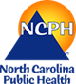 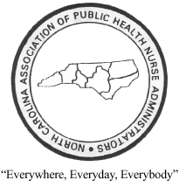 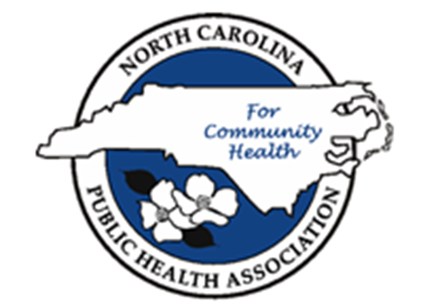

**Congratulations Distinguished 100!**

**Public Health Nurses are**

**North Carolina’s very best nurses!**

***Thank You* to everyone who helped in the process**

**of making this recognition happen.**

**The 100 Distinguished Public Health Nurses in NC**

**Awards Committee**

|  |
| --- |
| Susan Little, DNP, RN, PHNA-BC, CPH, CPHQ, CPM  2019 NCPHA Nursing Section Chair |
| Ellis Vaughan, DNP, RN  2019 NCAPHNA President |
| Phyllis Rocco, MPH, BSN, RN  NCDPH Chief Public Health Nurse |