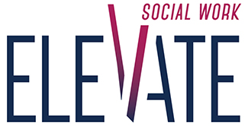
Certificate of Appreciation
Awarded To

_______________

In honor of Social Work Month and in recognition of your dedication and service towards improving the health and well-being of all North Carolina residents.

On the of March in the year 2019 North Carolina
Continuing Education, Training, and Advisory Committee (CETAC)

